Meet ____________________________

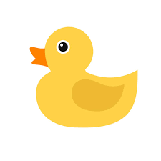
Students will get the chance to bring home our “class pet” for the weekend. It is an opportunity for your child to practice writing and reading skills in a fun and engaging way! It is optional, as I understand the weekends are a busy time for most families and I don’t want this to feel like just another homework assignment to complete.

The pet (rubber duck) will come home in a small backpack that will have a notebook, books to read with your family, and a list of activities. Please have your child write an entry journal-style in the notebook sometime during the weekend about what s/he did with our pet. S/he may include drawings and/or picture if s/he wishes, but I am mostly wanting them to focus on writing in complete sentences (about 5) that have legible handwriting, capital letters, and punctuation. Each student will be able to share their journal entry sometime during the following week. The pet will be due back in class each Monday. I hope this will be a fun experience for you and your child! Any questions, feel free to contact me!

